**Improving Power Grid Visualizations for Optimal Data Comparisons**

Cohen, Emma (ecohen2)

Clark, Michael (mtc3)

Miller, Paige (pmmille)

**Overview, Motivation, and Related Work**

Present power grid visualizations are designed in great detail to allow electrical engineers to accurately wire circuits. In an article published in the journal *IEEE Transactions on Visualization and Computer Graphics* titled “A Novel Visualization Technique for Electric Power Grid Analytics,” (1) it describes a novel technique for the visualization of power grids in which this report is based. One of the members of this team has a background in electrical engineering, specifically power analysis. This group member focuses their research on power grids, electrical substation wirings, and basic circuits. Concepts and techniques from the course are used throughout this project such as integrating the button function, bar graph visualization, and node graphs as taught by the instructor.

**Questions**

The visualizations derived from the article sought to answer the main question of “how can you both visually and interactively view busses (nodes) that use the most power?” This method of visualization will assist engineers in planning and monitoring power grids by giving them foresight into which parts of the grid are healthy, parts of the grid that can be improved, and where to prioritize maintenance. The manner in which the article is written allowed leeway with the questions posed, it gave visualization concepts that allowed the reader to frame the question to be answered based upon how

**Data**

The data for this project was collected from Clemson University during the summer of 2020. The data was missing for several time points and some of the points that were given were clearly measured incorrectly. The data set only had 15 nodes and about 10,000 time points. The website still shows this data visualized at the bottom, but it is clearly lacking. To remedy the data set, 26 nodes were added from the given one line diagram (also shown on the website) and their values were assigned based on the typical overall power consumption of Clemson University. The assigned values also change depending on the time of day, and instead of having data points every 15 minutes, the measurements now happen every hour. This helped reduce the amount of data so that more nodes could be added, since the number of nodes is more important to the visualization.

**Exploratory Data Analysis**

The data was given in a Microsoft Excel spreadsheet, with each node in a row and each column had a different time stamp. It was very challenging to see how the data would trend over time and which nodes showed the best trends. Even if the built in graphing functionality was used, the data was still shown in a way that was not at all similar to the IEEE study that the project is based off of. It wasn’t until the data was converted to a CSV file and made into a weighted node graph in JavaScript that it was really seen how much the data given was lacking. The insights from the first visualization really revolved around how the dataset needed to be changed in order to see the trends outlined in the IEEE paper.

**Design Evolution**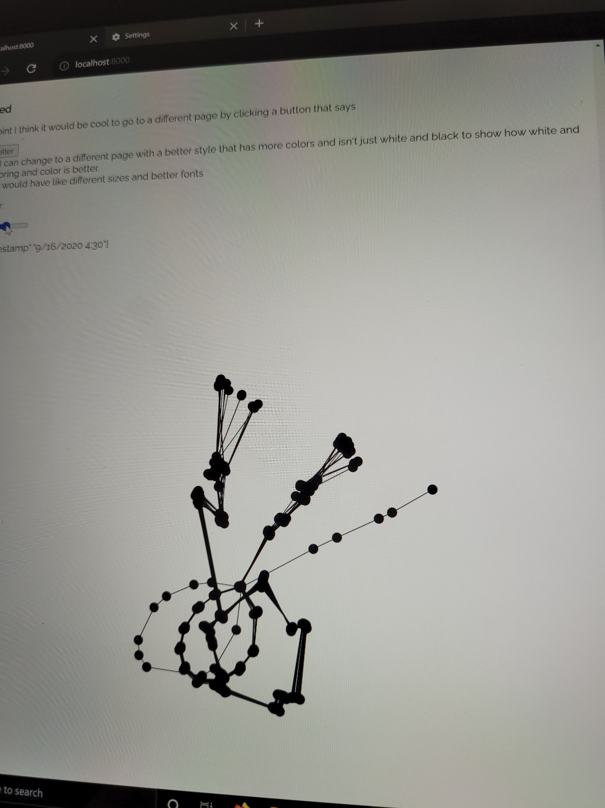

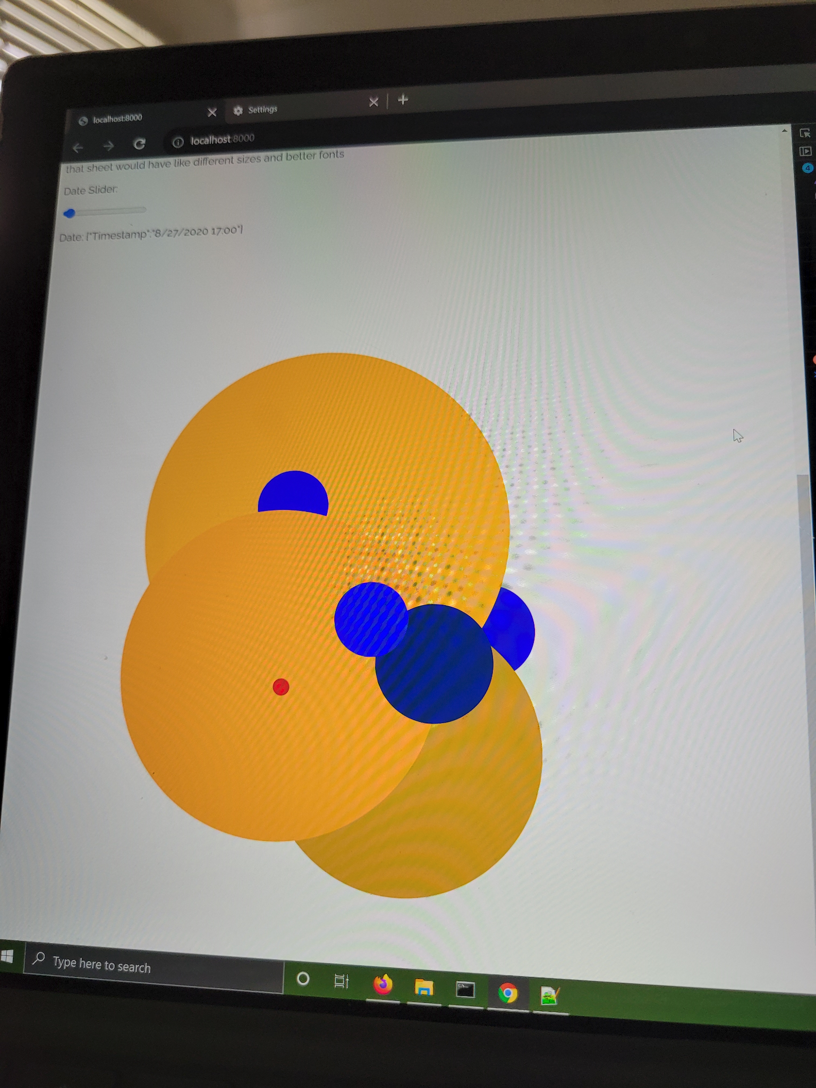

Figure 1. Iteration 1 of a weighted node graph. The image shows an attempt to make the slider update the node graph when switching between dates when sliding a slider without iterating on the old dates. However, the previous versions were not removed from the element between each refresh. Instead, it just looked silly flashing into and out of existence.

Figure 2. Early iteration of attempting to improve the visualization proposed in the paper using color and node size to provide more information.

The chosen research article outlines removing the geographic element of current power grid visualization and computationally expensive full scale renderings of large, sometimes nationwide, power grids in favor of weighted node diagrams. So, starting out the team knew it would be making a weighted node graph. Shown in Figure 1 is an early iteration of the node graph which the team attempted to have update positions based on the force simulation using a slider bar. The readings data is ordered by date and the slider would allow users to go to and visualize measurements for a new date. The team attempted to get the model to refresh after each date change. In the end, the team settled for having the forces iterate off the previous positions rather than have the graphs flash into and out of existence like in Figure 1.

Next, the team attempted to deviate from the base idea in the paper by adding size and color to the nodes as shown in Figure 2. The colors and node sizes updated much better than the forces when using the slider. However, as outlined in class, comparing the area of a circle and difference in color can be difficult. In the case of the designed visualization, changing the size and color of the nodes distracted extremely from the main point of the visualization outlined in the paper, which is the attractive and repulsive forces placed on the nodes and their links to show differences in measurements. When the nodes were changing size and color, even when transparent to see the links, it was more difficult to compare lengths and distance between nodes.

For the final version of the visualization, shown in Figure 3, the team chose to use simulated data instead of the real data because the original Cemson data was missing so many values that were causing the visualization to break completely. The Clemson visualization has the same features included for reference at the bottom of the page. Additionally, the team added a drop down menu to switch between the measures being visualized. Scrolling will change the date being visualized. However, the values are too similar. Once the forces are set the visualization does not change. If the slider is moved while the forces are still settling it will shift slightly, but overall the x and y values when computed by the forces are so similar they’re essentially the same. If you use the console log you can see that the values being input into the force simulation are changing, just not the coordinates. In Figure 3, the utilization of the visualization techniques are clear. Areas where the nodes are more spread have high values of the measurements and areas where they are more clumped are smaller values. In this example Watts are visualized and it’s easy to see which areas or nodes are pulling more power. Switching to a different measurement with the drop down menu will refresh the visualization, but because of the data types available, they are similar and look the same. 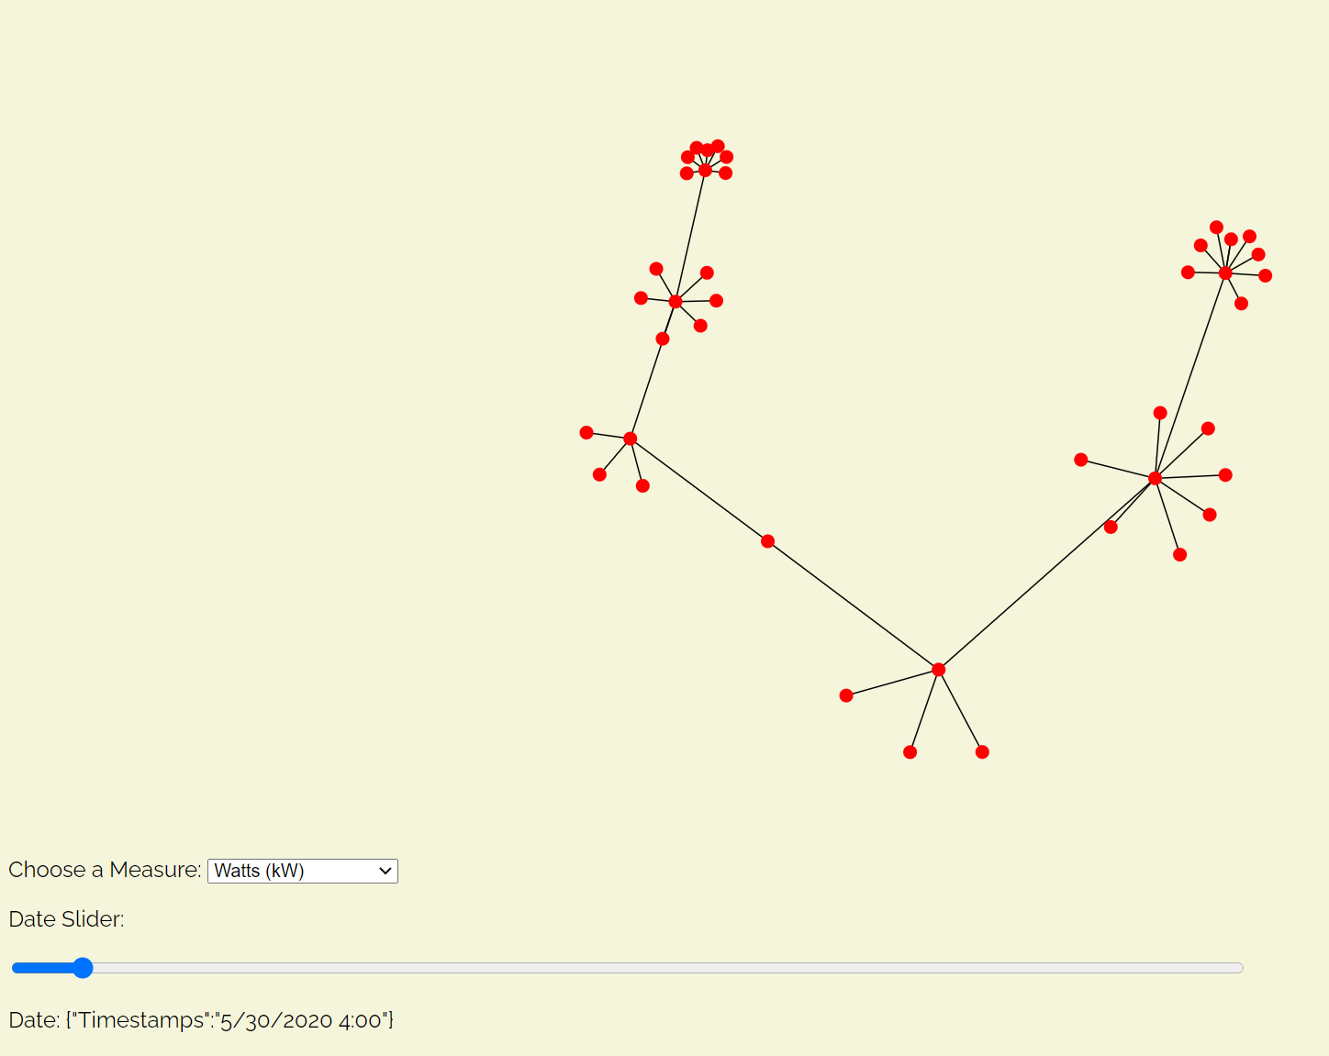

Figure 3. Final iteration of visualization.

The example visualization originally was represented with a picture shown in Figure 4 and a lot of explanatory text. So, for the final visualizations, the team implemented interactive versions of the figure and text with step by step instructions on how to utilize the final visualization.

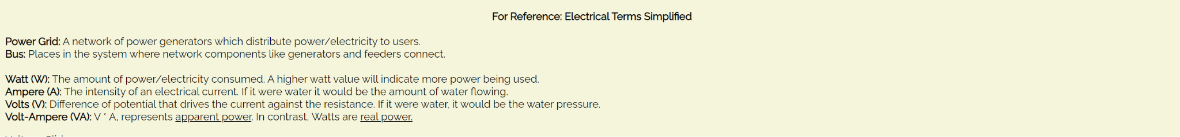

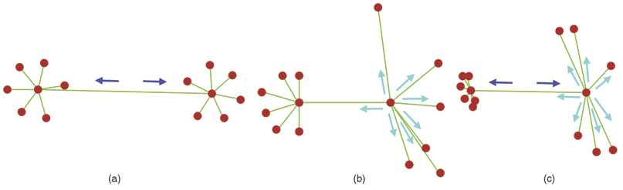

Figure 4 Original Example (above).

Figure 5 Electrical Terms Simplified as a Visualization (below).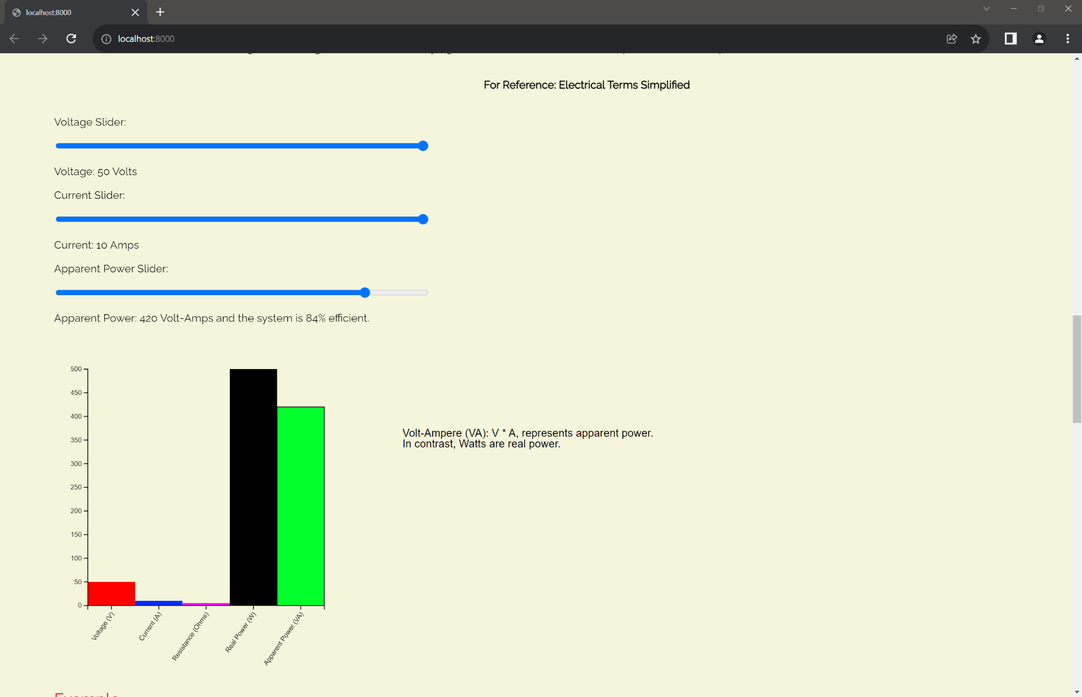

To replace the block of definitions shown in Figure 4 and add more interactivity, a bar graph was created as shown in Figure 5. This shows the relationship between the units used in the visualizations. To visually show it, by sliding the sliders to different values, one can see the bars for corresponding units raise or lower to represent how the values relate to each other. For example, lowering the Watts will lower the Volts or Amps, but lowering the Volt-Amperes (apparent power) will not affect the other values and instead relates to the efficiency. Lastly, hovering over the bars will outline the bar and provide the definition for the corresponding term.

**Implementation**

Section 1: Example/Tutorial

To show users how to use the visualization, the team included an example visualization with step by step instruction as a walk through for its utilization. The team added an additional SVG element to include the instructions which change as one goes through the steps. The only thing the example has compared to the final visualization is the ‘Add Links and Nodes’ and ‘Reset’ button which show the users the utilization of the weighted node graph compared to an unweighted visualization confined geographically.

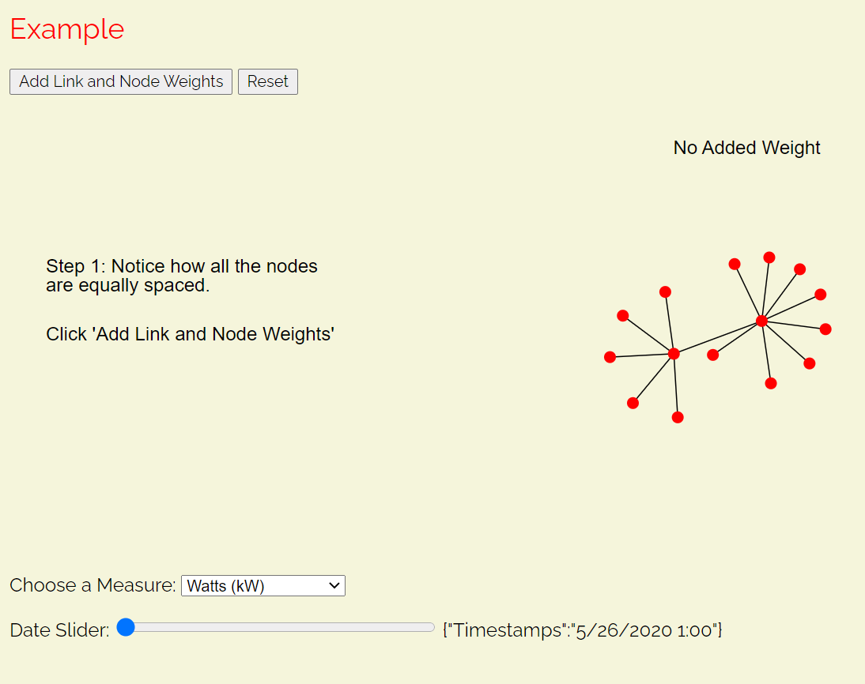

First, the user can see an unweighted graph. Following the instructions and clicking the button will add weights to the graph and include an explanation of how to read/utilize the image. When following the instructions the label also changes from ‘No Added Weight” to Weight Added.’

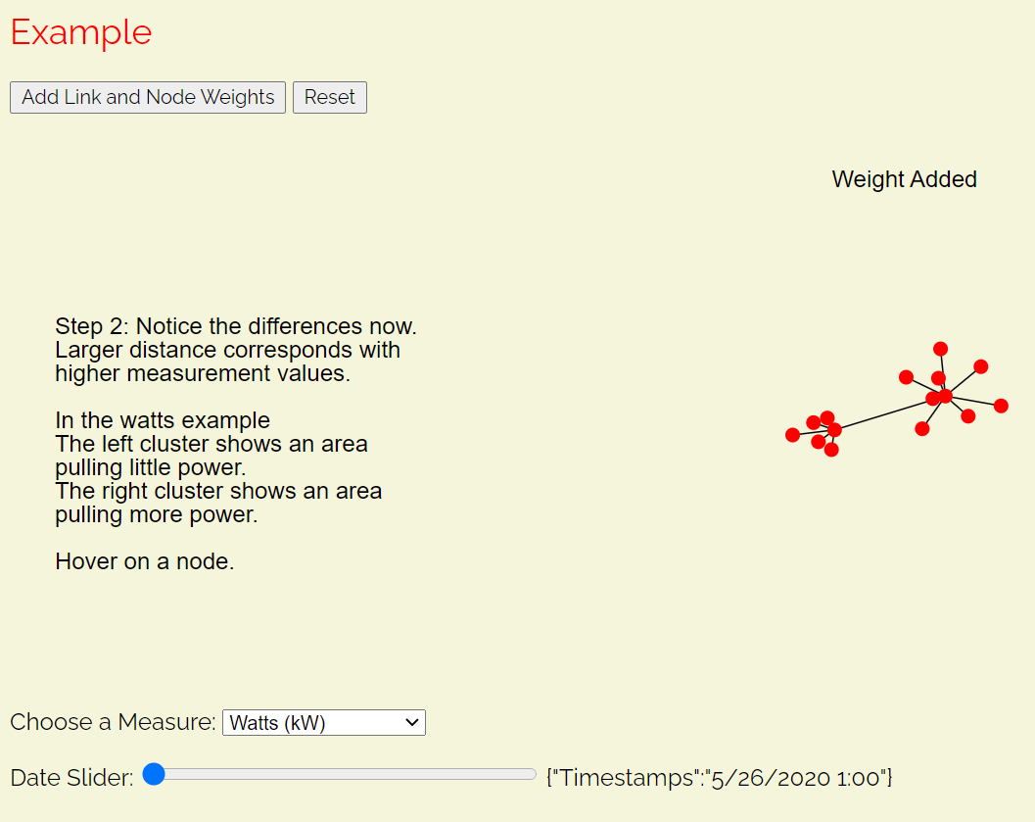

The example given is for Watts, but the example shows how clear the difference between weighted and unweighted is.

Following the next step and hovering over the node will give an explanation of what the node is in real life, its relevance in the power grids and visualization, and show the user where to find additional information in the final visualization.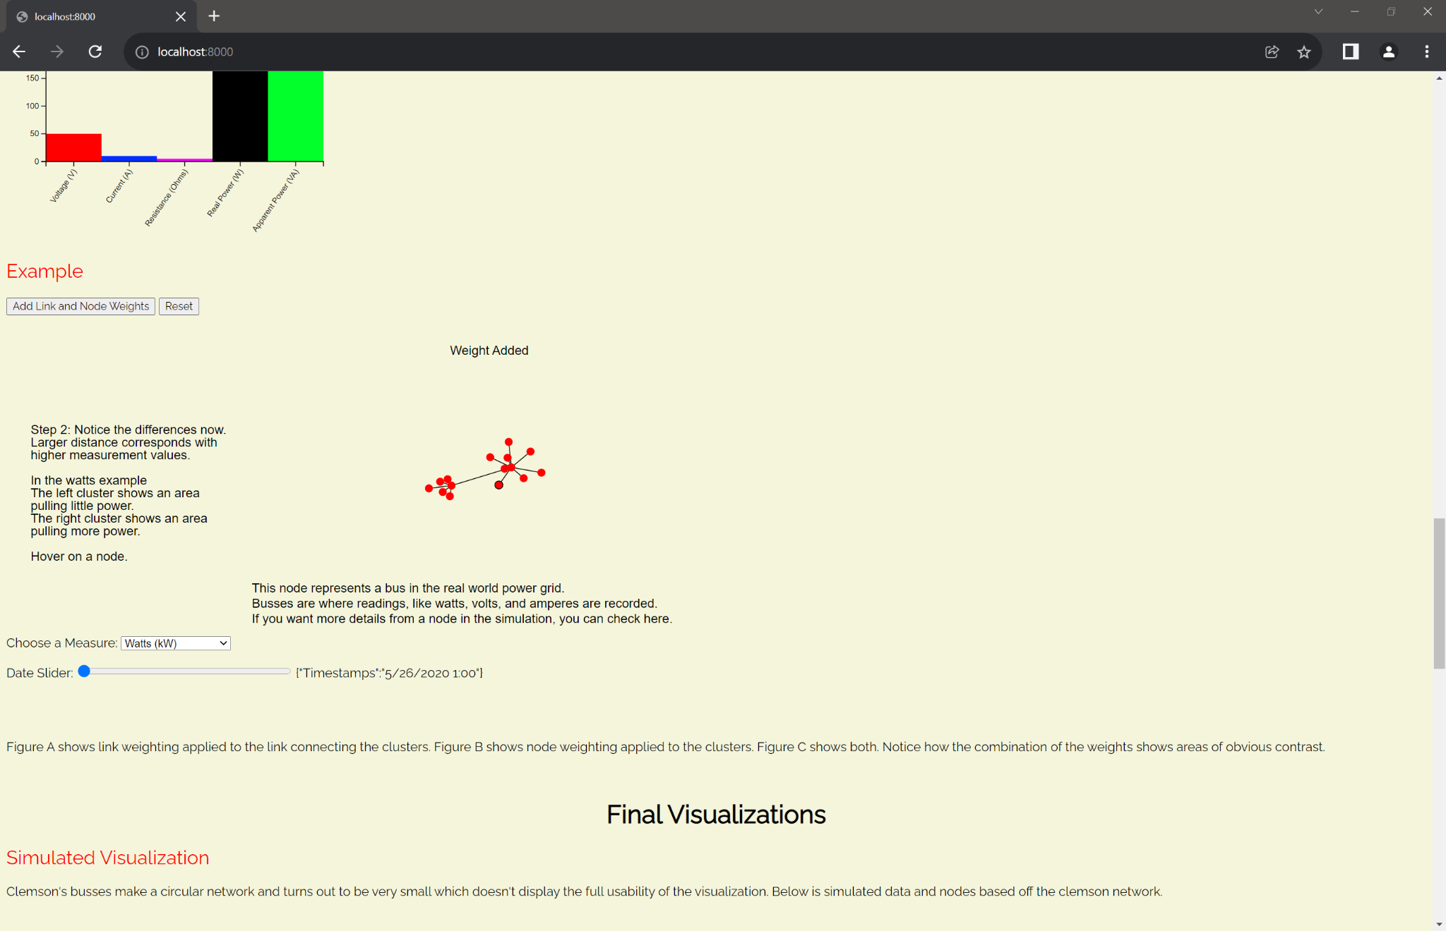

Hovering over a node outlines it in black. The user can see the bottom left node of the larger cluster has the outline in the image below.

For the final steps in the example visualization the user is instructed to use the date slider to view the visualization at different dates. The example suffers from a similar problem that once the forces are settled the visualization doesn’t move. Lastly, users are instructed to utilize the drop down menu to view the visualization for other measures in the data. Doing so in the example will refresh the simulation. The reset button will also refresh everything and start from step 1.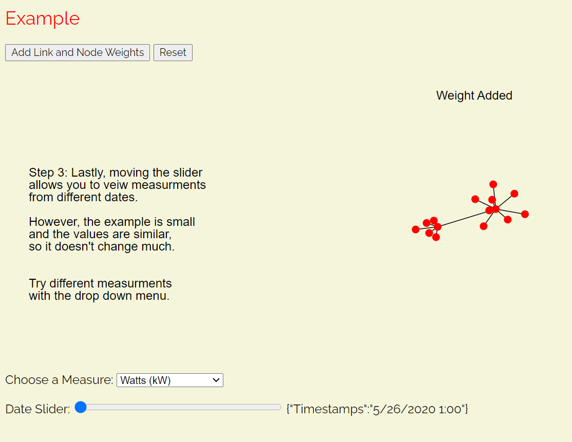

In summation, the interactive features of the visualization are:

1. In the example visualization only, being able to click the ‘Add’ and ‘Reset’ buttons to go between an unweighted and weighted node graph to compare the differences, and having labels and instructions update as you interact with it.
2. Hovering over the node to get the “Node Name” and “Reading” for your specified measurement.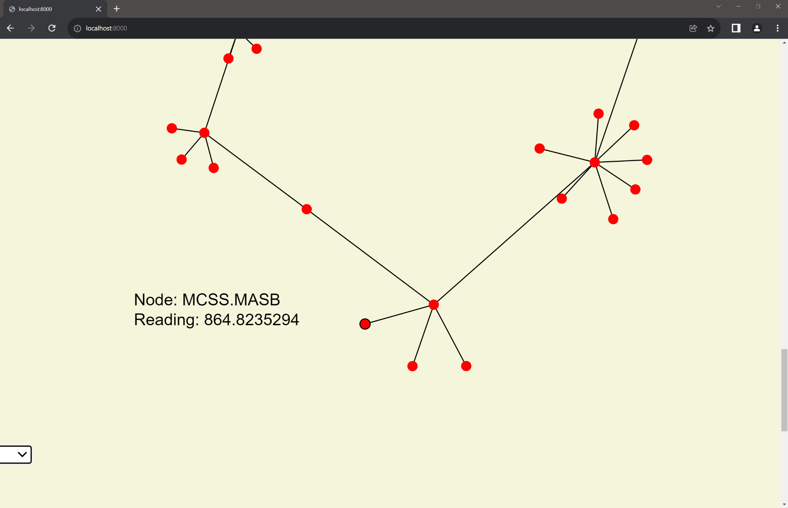
3. Using the drop down menu to select different options for measurements to view. Which restarts the visualization.

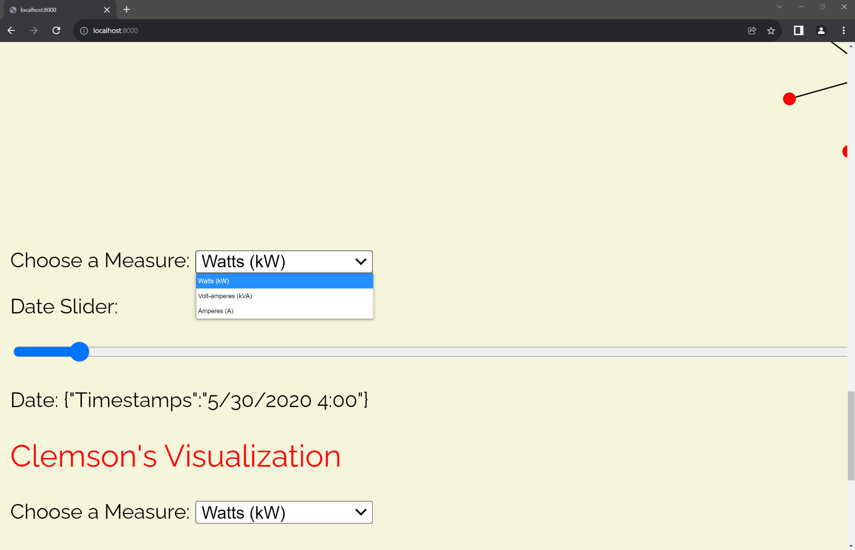

1. Using the Date Slider to get data from different dates. Moving the date slider also updates text to tell the user the specific date and time so the user can search for and find a specific date to reference. After changing the slider users can hover over the node again and see the reading has updated. This example also shows how similar the values are between dates.

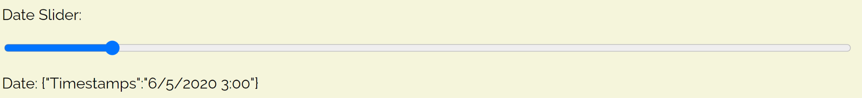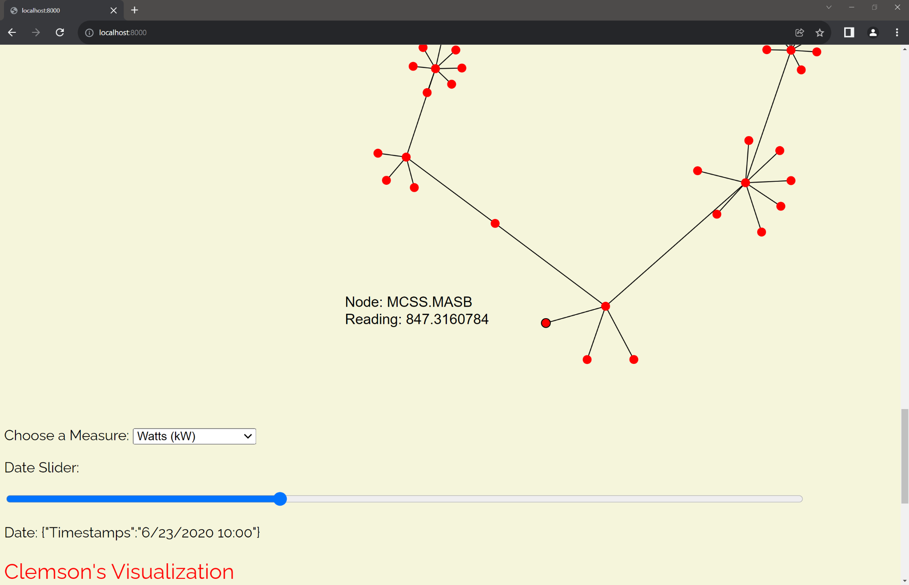

1. Changing the slider values in the Electronic Terms Simplified visualization will affect the levels of the bar graph according to the unit relationships. The lines underneath the sliders give additional information as well.
2. Hovering over each bar will outline the bar and the definition will appear for reference.

**Evaluation**

One of the main things we can conclude about the data is that Clemson’s power grid is extremely consistent. There is very little variation day to day in readings and the circular shape of the network doesn’t lend itself well to a force directed node weighted graph. However, the simulated data shows how one can use the weighted graph to compare which nodes and clusters are pulling the most power or should be pulling the most power based on their apparent power. Given more time, there are several improvements that could be made to the visualization. One that was introduced in the IEEE report is to have the nodes combine when the zoom out feature is added. This allows for less computational power to be utilized while still showing an accurate visualization of the data. Another improvement would be to exaggerate the forces on each node to show more detail when the changes are as slight as they are in the Clemson dataset. While the best effort was put forward to recreate the IEEE report, more time would have allowed for further improvements and added features.

**References:**

(1) P. C. Wong et al., "A Novel Visualization Technique for Electric Power Grid Analytics," in IEEE Transactions on Visualization and Computer Graphics, vol. 15, no. 3, pp. 410-423, May-June 2009, doi: 10.1109/TVCG.2008.197. https://ieeexplore.ieee.org/document/4695829